**PEDESTRIAN**

**AND VEHICLE DETECTOR**

-ABHIJEET PADHI

(RA1911003010393)

SHIVAM PANDEY

(RA1911003010383)

MAYANK SINHA

(RA1911003010386)

**OVERVIEW**

AS THE NAME SAYS **PEDESTRIAN AND VEHICLE DETECTOR** DETECTS PEOPLE AND OTHER VEHICLES BEFOREHAND AND GIVES YOU THE INDICATIONS**.**

THIS SOFTWARE WORKS AS A DRIVER ASSISTANCE SYSTEMS AIMING TO ALERT DRIVERS ABOUT DRIVING ENVIRONMENTS AND POSSIBLE COLLISION WITH OTHER VEHICLE OR PEOPLE. THIS SOFTWARE ACTUALY REPLACES A **MAGNETOMETER** WHICH WORKS BY USING PASSIVE SENSING TECHNOLOGY TO DETECT LARGE FERROUNS OBJECTS BY MEASURING MAGNETIC FIELD. BUT IT WAS NOT VERY ACCURATE SO THIS METHOD BECOMES A BIT DANGEROUS AT HIGH SPEED.

AS THE AUTOMOBILE INDUSTRY IS ENTERING INTO SELF DRIVING CARS, THIS SOFTWARE IS AN ESSENTIAL FEATURE OF THESE CARS. AFTER TESLA AND OTHER BIG BRANDS COMING INTO THE INDIAN MARKET WITH SUCH SIMILAR SOFTWARE IN THEIR VEHICLE, THE INDIAN CAR MAKING COMPANIES DEFINITELY NEED THIS SOFTWARE TO COMPETE WITH THEM.

THIS SOFTWARE WORKS EXTREMELY WELL WITH AUTOMATIC EMERGENCY BRAKING SYSTEM WHICH IS DESIGNED TO AUTOMATICALLY ENGAGE THE BRAKES TO REDUCE THE IMPACT OF AN UNAVOIDABLE FRONTAL COLLISION. **AS WE TURN ON THE VEHICLE IT COMES INTO POWER AND IT SCANS THE ENVIROMENT, MARKING THE PEDESTRIANS IN GREEN AND OTHER VECHILES IN RED, AND SHOWS IT ON THE SCREEN.**

THIS SOFTWARE IS BETTER THAN THE OLD TECHNOLOGY AS IT SHOW THE EXACT PICTURES OF WHAT IS IN THE SURROUNDING OF THE VEHILCE WITHOUT MISSING ANY.

THIS SOFTWARE CAN ALSO BE USED BY OTHER AGENCIES ALONG WITH THE STREET SIGNALS IN KEEPING TRACK OF THE SPEED LIMITS AND KEEPING A PROPER CEHCK ON THE TRAFFIC.THIS SOFTWARE CAN ALSO BE USED BY THE MILITARY IN DRONES AND OTHER VEHICLES IN DETECTING THE ENEMIES FROM FAR RANGE WITHOUT RISKING ANY OF THEIR LIVES.THIS SOFTWARE CAN BE USED BY MULTIPLE COMPANIES IN MULTIPLE WAYS FOR THE SECURITY AND SAFETY OF THE CUSTOMERS.

**THIS SOFTWARE WORKS IN FOLLOWING STEPS:**

* FIRST IT CHECKS FOR THE CAMERA TO RUN UNTIL WE COMMAND IT TO STOP.
* IT CAPTURES THE LIVE COLOURED RUNNING IMAGES AND TURN IT INTO BLACK AND WHITE FOR EASY DETECTION.
* THIS SOFTWARE USES THE **PRETRAINED HAAR CASCADE (**it is a machine learning based approach where a cascade function is trained from a lot of positive and negative images.it is then used to detect objects in other images**)** MODEL FOR THE DETECTION.
* WE GET ALL THE COORDINATES, HIGHT AND WIDTH OF THE REGION OF THE VEHICLES AND THE PEDESTRIANS.
* THEN IT SHOW THE VIDEO WITH RECTANGLE BOXES AROUND THE DETECTED VEHICLES AND PEDESTRIANS SIGNNALING DANGER IF ANY.
* THE SOFTWARE KEEPS THE VIDEO FEED ON UNTIL WE COMMAND IT TO SHUT DOWN.

**ARCHITECTURE DIAGRAM**

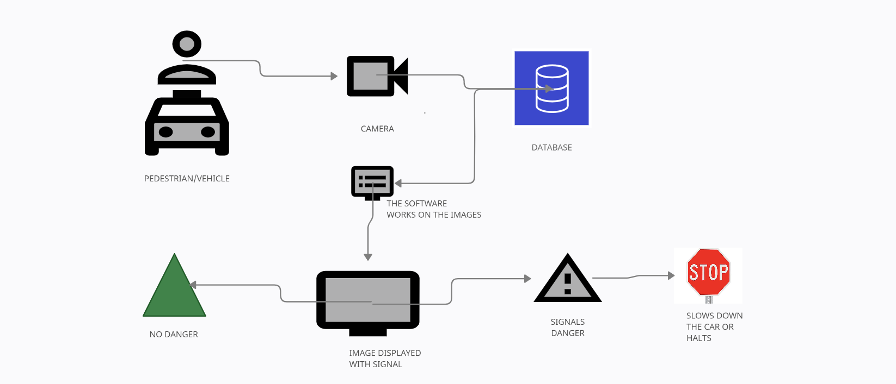

**CHALLENGES AND ISSUES:**

* THIS SOFTWARE COMPLETELY DEPENEDS UPON THE DATA AND PERFORMANCE OF THE SOFTWARE.
* A SLIGHT CHANGE IN LIGHTNING CONDITION CAUSE A SIGNIFICANT CHALLENGE FOR AUTOMATED RECOGNITION AND CAN HAVE A SIGNIFICANT IMPACT ON THE RESULTS.
* OCCLUSION WHICH MEANS BLOCKAGE AND IT OCCURS WHEN OTHER PARTS OF THE FACE ARE BLOCKED AND THE WHOLE IMAGE IS NOT AVAILABLE AS AN INPUT IMAGE.
* INCORRECT CAMERA USED WITH NO FIXED IRIS, HIGH SHUTTER SPEED OR BAND PASS FILTER.
* IT DOES NOT WORK PROPERLY IF THE SUBJECT MOVES VERY FAST.
* EXCESSIVE SKEW ANGLES CAUSING RECOGNITION ISSUES.

**Business Case Template:**

|  |  |
| --- | --- |
| **DATE:** | **6.2.2021** |
| **SUBMITTED BY:** | **ABHIJEET PADHI(RA1911003010393), SHIVAM PANDEY(RA1911003010383), MAYANK SINHA(RA1911003010386)** |
| **TITLE:** | **PEDESTRIAN AND VEHICLE DETECTOR** |

**THE PROJECT**

● MOST IMPORTANT FEATURE OF SELF-DRIVEN CARS.

● DETECTS HUMANS AND OTHER VEHICLE.

● REDUCES WORKLOAD ON HUMANS.

● VERY SAFE COMPARED TO OTHER TECHNOLOGIES.

**THE HISTORY**

● MAGNOMETER WASN’T SUCCESFULL.

● PEOPLE FALL ASLEEP WHILE DRIVING.

● LOTS OF ACCIDENTS DUE TO POOR VISION.

**LIMITATIONS**

● IT REQUIRES A GREAT CAMERA.

● CAMERA ANGLE SHOULD BE CORRECT.

● OBJECT ON THE FRONT SHOULD BE AT MODERATE SPEED.

**APPROACH**

● CODING SKILLS.

● SOFTWARE MANAGEMENT AND DEVELOPMENT SKILLS.

● BASIC KNOWLEDGE ABOUT FACE DETECTOR.

**BENEFITS**

● SHOWS DANGER BEFOREHAND.

● MORE RELIABLE.

● SELF DRIVING FACILITY.

● EASY AND ACCURATE CALCULATIONS.

**USER STORY TEMPLATE**

|  |  |  |  |
| --- | --- | --- | --- |
| **USER STORY ID** | **AS A (TYPE OF USER)** | **I WANT TO (PERFORM SOME TASK)** | **SO THAT I CAN (ACHIEVE SOME GOAL)** |
| **1** | **PROJECT MANAGER** | **VIEW A STATUS REPORT FROM EACH TEAM MEMBER.** | **ENSURE THE PROJECT STAYS ON TRACK.** |
| **2** | **EMPLOYEE** | **BE REMINDED OF UPCOMING DEADLINE.** | **COMPLETE MY TASK ON TIME.** |
| **3** | **CUSTOMER** | **PUSRCHASE THE PRODUCT.** | **AND GET THE BENFITS OF THE FEATURES.** |
| **4** | **CUSTOMER** | **USED BY THE TRAFFIC POLICE.** | **USE THIS SYSTEM FOR MAKING THE WORK EASIER.** |
| **5** | **CUSTOMER** | **GIVE FEEDBACK ABOUT THE SOFTWARE.** | **IMPROVE OR SOFTWARE ACCORDING TO THE FEEDBACK RECEIVED.** |
| **6** | **DEVLOPER** | **USE THE FEEDBACK AND UPDATE THE SOFTWARE.** | **IMPROVE THE SOFTWARE TO MEET THE NEEDS OF THE CUSTOMERS.** |

**STAKE HOLDER TEMPLATE**

|  |  |
| --- | --- |
| PROJECT NAME: | PEDESTRIAN AND VEHICLE DETECTOR. |
| PREPARED BY: | MAYANK SINHA (RA1911003010386), SHIVAM PANDEY(RA1911003010383), ABHIJEET PADHI(RA1911003010393) |
| DATE: | 6TH FEBRUARY-2021. |

|  |  |  |  |  |
| --- | --- | --- | --- | --- |
| PROJECT STAKEHOLDER NAME | SPECIFIC INFORMATION NEEDS | PROJECT INTERESTS | IMPACT ON PROJECT | ROLE |
| AMIT | PROVIDES INSTRUCTIONS AND GAUIDANCE | SALARY, SHARE PORTIONS, DECISION MAKING | POSITIVE SUPPOTER | DIRECTORIAL  /MANAGEMENT |
| ALINJAR | INFORMATION ON SOFTWARE POLICIES | DIRECTLY ENGAGED WITH THE SOFTWARE | POSITIVE SUPPORTER | EMPLOYEE |
| LAVESH | INFORMATION ON POTENTIAL GROWTH AND NEW COMPETITION IN MARKET | INFULENCE THE OVERALL SALES OF THE SOFTWARE | SUPPOTER/  INFLUENCER | CUSTOMERS |
| TANMAY | NIL | ADVICE FOR THE BETTER FUNTION OF THE SOFTWARE | SUPPOTER | ADVISORS |
| ARADHAYA | REGULAR COMMUNICATIONS  SOFTWARE POLICIES AND PRACTICES | LEGISLATION AND REGULATIONS OF THE SOFTWARE. | INFLUENCER | GOVERNMENT |
| SIDDHART | NIL | PUBLIC IMAGE/ REPUTATION | INFLUENCER | RATING AGENCIES |